**Enrichment – Power Cortland Watson**

Part I – Individual Quiz (Before Class)

Part II – Group Quiz (During Class)

1. What is the notation for a BF[1] model (4 pts)?

Observed Value

Benchmark (Grand mean)

Conditioned Effect

Residual Error

Y=Mu + Alpha(j) +Epsilon(ij)

**End of Part I**

1. Were you in class on time (2 pts)?

Yes

1. For Fish Data $x_{23}=___3.9___$ $x_{12}=__5.2___$ $x_{41}=___4.8___$ (2 pts)
2. Suppose we are planning a fruit fly study (3 points).

α =0.05

n =20 observations per group

I = 4 groups

Would like to consider power for the case where four of the groups have the same $α_{i}=c, where i=1,2,3$ and one group has $α_{4}=c+5$.

Assume that nearly all (about 99.7%) of flies live between 30 and 100 days. ($σ≅11.67$)

**Determine the power of this test.**

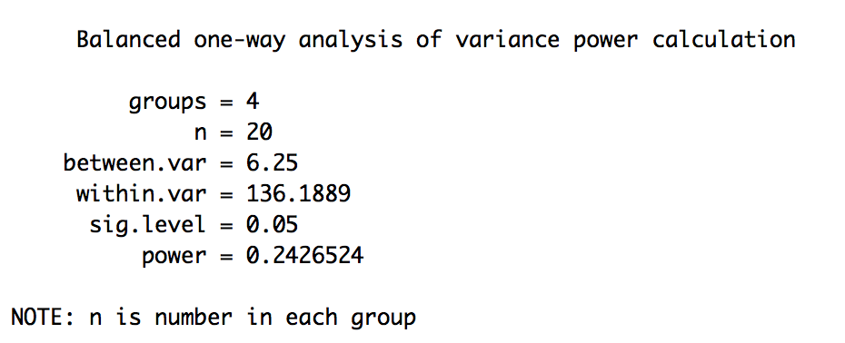

Suppose we are planning a fruit fly study (3 points).

α =0.05

Power = 0.85

I = 4 groups

Would like to consider power for the case where four of the groups have the same $α_{i}=c, where i=1,2,3$ and one group has $α_{4}=c+5$.

Assume that nearly all (about 99.7%) of flies live between 30 and 100 days. ($σ≅11.67$)

**Determine the sample size needed per group for this test.**

